**What is a REST API?**

In this lesson, you will get an insight into the REST API

**We'll cover the following**

* + [What is REST?](https://www.educative.io/courses/web-application-software-architecture-101/qADAzX6yorR#What-is-REST?)
  + [REST API](https://www.educative.io/courses/web-application-software-architecture-101/qADAzX6yorR#REST-API)
  + [REST endpoint](https://www.educative.io/courses/web-application-software-architecture-101/qADAzX6yorR#REST-endpoint)
  + [Decoupling clients and the backend service](https://www.educative.io/courses/web-application-software-architecture-101/qADAzX6yorR#Decoupling-clients-and-the-backend-service)
  + [Application development before the REST API](https://www.educative.io/courses/web-application-software-architecture-101/qADAzX6yorR#Application-development-before-the-REST-API)
  + [API Gateway](https://www.educative.io/courses/web-application-software-architecture-101/qADAzX6yorR#API-Gateway)

**What is REST?**[#](https://www.educative.io/courses/web-application-software-architecture-101/qADAzX6yorR#What-is-REST?)

*REST* stands for *Representational State Transfer*. It’s a software architectural style for implementing *web services*. *Web services* implemented using the *REST* architectural style are known as the *RESTful web services*.

**REST API**[#](https://www.educative.io/courses/web-application-software-architecture-101/qADAzX6yorR#REST-API)

A *REST API* is an *API* implementation that adheres to the *REST* architectural constraints. It acts as an interface. The communication between the *client* and the server happens over *HTTP*. A *REST API* takes advantage of the *HTTP* methodologies to establish communication between the *client* and the *server*. *REST* also enables *servers* to *cache* the response that improves the application’s performance.

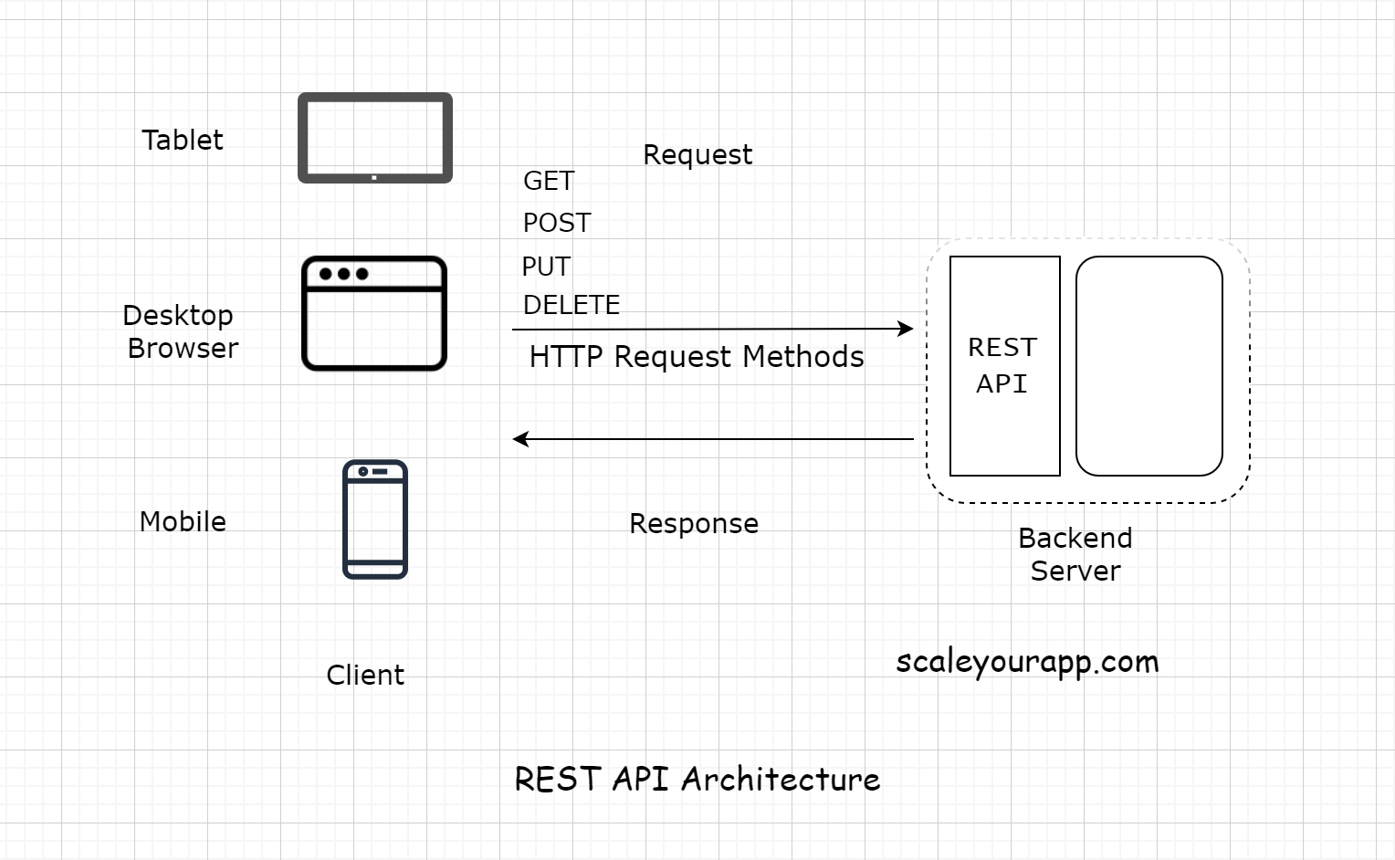

The communication between the client and the server is a stateless process. By that, I mean every communication between the client and the server is like a new one.

There is no information or memory carried over from the previous communications. So, every time a client interacts with the backend, the client has to send the authentication information to it as well. This enables the backend to figure out whether the client is authorized to access the data or not.

When implementing a *REST API*, the client communicates with the backend endpoints. This entirely decouples the backend and the client code.

Let’s break it down what this means.

**REST endpoint**[#](https://www.educative.io/courses/web-application-software-architecture-101/qADAzX6yorR#REST-endpoint)

An *API/REST/Backend* endpoint means the *URL* of the service that the client could hit. For instance, https://myservice.com/users/{username} is a backend endpoint for fetching the user details of a particular user from the service.

The *REST-based* service will expose this *URL* to all its clients to fetch the user details using the above stated *URL*.

**Decoupling clients and the backend service**[#](https://www.educative.io/courses/web-application-software-architecture-101/qADAzX6yorR#Decoupling-clients-and-the-backend-service)

With the availability of the endpoints, the backend service does not have to worry about the client implementation. It just calls out to its multiple clients and says, “*Hey Folks! Here is the URL address of the resource/information you need. Hit it when you need it. Any client with the required authorization to access a resource can access it*”.

With the *REST* implementation, developers can have different implementations for different clients, leveraging different technologies with separate codebases. Different clients accessing a common *REST API* could be a mobile browser, a desktop browser, a tablet or an *API* testing tool. Introducing new types of clients or modifying the client code does not affect the functionality of the backend service.

This means the clients and the backend service are decoupled.

**Application development before the REST API**[#](https://www.educative.io/courses/web-application-software-architecture-101/qADAzX6yorR#Application-development-before-the-REST-API)

Before the *REST-based API* interfaces became mainstream in the industry, we often tightly coupled the backend code with the client. *Java Server Pages* (JSP) is one example of this.

We would always put *business logic* in the *JSP* tags. This made code refactoring and adding new features difficult because the business logic spread across different layers.

Also, on the backend, we had to write separate code/classes for handling requests from different types of clients. We needed a separate servlet for handling requests from a mobile client and a separate one for a web-based client.

After *REST APIs* implementation backend developers didn’t need to worry about the type of the client. All the devs had to do was provide the service endpoints to the clients and they would receive the response in a standard data transport format like *JSON*. It was now the responsibility of the clients to parse and render the response data.

This cut down a lot of unnecessary work for the backend developers. Also, adding new clients became a lot easier. Now, with *REST*, we can introduce any number of new clients without having to worry about the backend implementation.

In today’s application development landscape, there is hardly any online service implemented without a *REST API*. Want to access the public data of any social network? Just use their *REST API*.

**API Gateway**[#](https://www.educative.io/courses/web-application-software-architecture-101/qADAzX6yorR#API-Gateway)

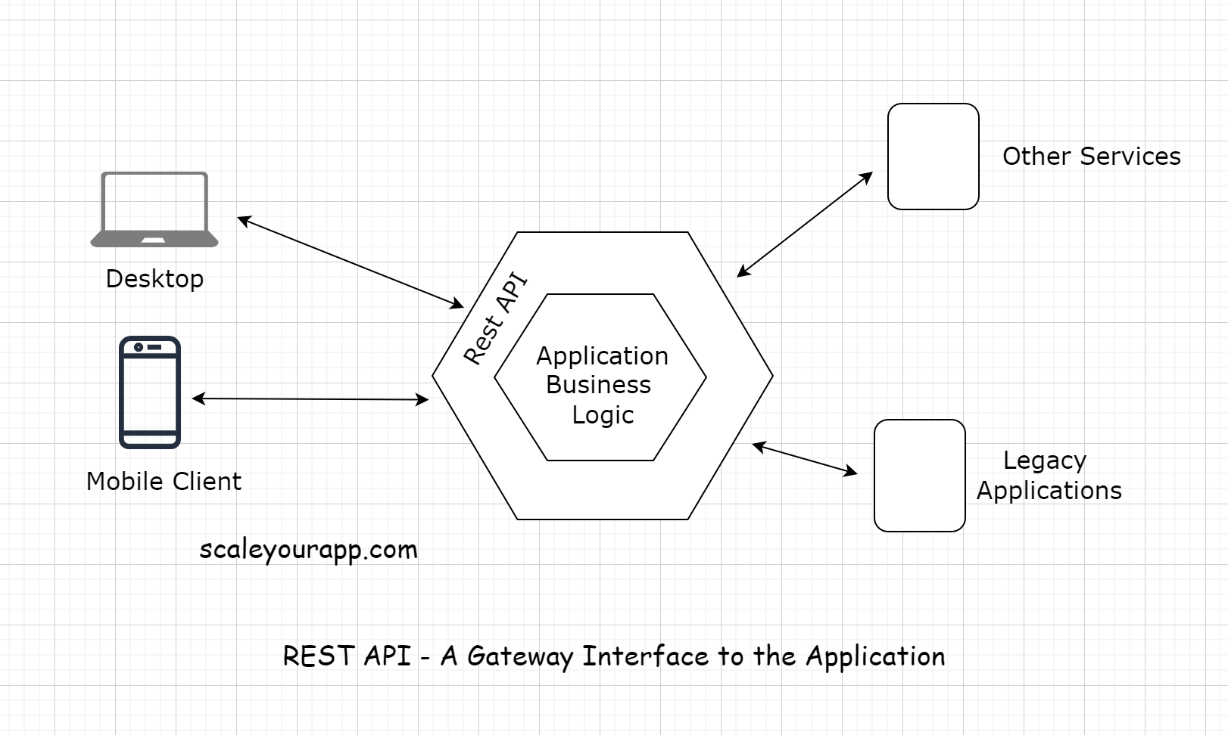

The *REST-API* acts as a gateway or a single-entry point into the system. It encapsulates the *business logic* and handles all the *client* requests, taking care of the authorization, authentication, sanitizing the input data, and other necessary tasks before providing access to the application resources.

So, now we are aware of the *client-server* architecture. We also know what a *REST API* is. It acts as the interface, and the communication between the client and the server happens over *HTTP*.

Now, let’s look into the *HTTP Pull* and *Push-based* communication mechanism in the lesson up next.